


PROJECT PROPOSAL

TRADE TRAINING SCHOOL (TTS) MANAGEMENT PORTAL

FORMATION | SLAF TTS EKA
DATE OF ORIGINATED | July 2026
COURSE | Computer Technician

SRI LANKA AIR FORCE TRADE TRAINING SCHOOL EKALA
PROJECT REPORT
01 |  |  |  | Final Outcome of the Project
The outcome of this project is to design and implement a Trade Training School (TTS) Management Portal for the Sri Lanka Air Force Trade Training School, Ekala, to digitalize and integrate the administration, discipline, academic, accommodation, and mess management functions into a single centralized platform.
The system will provide a centralized database that enables all authorized sections to access and manage trainee information in real time, ensuring data consistency, operational efficiency, accountability, and informed decision-making. It will eliminate duplicate data entry by allowing all modules to share the same trainee records while maintaining role-based access control and complete audit trails.
The completed system will be capable of:
- Maintaining a centralized database for all trainee and staff information.
- Managing trainee personal records, batch details, and daily parade state.
- Managing accommodation details, including billets, bed allocations, occupancy, and facilities.
- Managing academic activities such as course management, lesson planning, instructor allocation, attendance, phase tests, final examinations, and student performance.
- Automatically synchronizing trainee status across all related modules. For example, if the Discipline Section updates a trainee's Daily Parade State as Sick Report, Hospital, Leave, or Course Visit, the Academic, Accommodation, Mess Management, Dashboard, and Reporting modules shall be updated automatically without requiring duplicate data entry.
- Generating real-time dashboards, operational statistics, and management reports for officers and the Training Warrant Officer.
- Improving operational efficiency by minimizing paperwork, reducing administrative workload, enhancing data accuracy, and providing faster access to information.

02 |  |  |  | Project Summary
The proposed Trade Training School (TTS) Management Portal aims to digitize and centralize the administrative and training management activities of the Sri Lanka Air Force Trade Training School in Ekala.

The system will provide the following features:
- Develop a centralized web-based management portal for the Trade Training School.
- Maintain a single centralized database for all trainee and staff information.
- Manage trainee personal records, service details, and batch information.
- Manage the Daily Parade State by the Discipline Section.
- Manage accommodation details, including buildings, billets, bed allocations, occupancy, and facilities.
- Manage academic activities such as course management, lesson planning, instructor allocation, attendance, phase tests, final examinations, and student performance.
- Manage daily meal planning, ration management, and system-based meal verification.
- Automatically synchronize trainee status across all related modules.
- Eliminate duplicate data entry by allowing all departments to use the same trainee information.
- Generate real-time dashboards, analytical reports, and operational statistics for management.
- Implement role-based access control to ensure secure access to information.
- Maintain complete audit logs for accountability and system security.
- Reduce paperwork, manual processes, and administrative workload.
- Improve data accuracy, operational efficiency, and decision-making throughout the Trade Training School.

03 |  |  |  | Benefits of the Project
- Minimizes the use of paper-based records and manual documentation.
- Reduces duplicate data entry through a centralized database.
- Improves the accuracy and consistency of trainee information across all departments.
- Enables real-time synchronization of trainee status between all system modules.
- Simplifies the management of trainee personal records, accommodation, academic activities, and mess administration.
- Improves monitoring of daily parade state and trainee strength.
- Provides efficient billet, bed allocation, and accommodation occupancy management.
- Streamlines course, lesson, instructor, examination, and student performance management.
- Enhances meal planning and ration management through system-based meal verification.
- Generates real-time dashboards, operational statistics, and management reports.
- Improves communication and coordination among the Discipline Section, Academic Section, Accommodation Section, Mess Section, and management.
- Strengthens data security through role-based access control and audit logging.
- Reduces administrative workload and saves time for all departments.
- Supports faster and more accurate decision-making by providing real-time information.
- Improves overall operational efficiency of the Sri Lanka Air Force Trade Training School.

04 |  |  |  |  |  |  | Project Planning
- Requirement gathering and stakeholder discussions.
- Analyze the existing manual system and identify problems.
- Define the project scope and objectives.
- Prepare the Software Requirements Specification (SRS).
- Design the overall system architecture and database.
- Develop the implementation schedule and resource plan.

05 |  |  |  |  |  |  |  | Project Implementation Plan
- Set up the development environment.
- Design the MySQL database and system architecture.
- Develop the frontend using React.js.
- Develop RESTful APIs using FastAPI.
- Integrate the frontend, backend, and database.
- Implement authentication and role-based access control.
- Conduct system integration and testing.
- Deploy the system and perform user acceptance testing.

06 |  |  |  | Project Plan
S/No | Project tasks | Planned |  |  |  |  | Executed |  |  |  |  | Reasons for Deviations
S/No | Project tasks | July |  |  |  |  | Aug |  |  |  |  | Reasons for Deviations
S/No | Project tasks | 1 | 2 | 3 | 4 | 5 | 1 | 2 | 3 | 4 | 5 | Reasons for Deviations
01 | Requirement Analysis
02 | System Design
03 | Database Design
04 | Module Development
06 | System Integration
07 | System Testing
08 | Documentation
09 | User Training

07 | Student Participation in the Project
S/No | Svc No | Rank | Name | Competency Part of the project Role
01 | 49928 | LAC | Jayarathne SGTC | UI Design
02 | 50327 | LAC | Rashmika MS | Authentication & Security of the system
03 | 50691 | LAC | Darshana LBPT | Modules development of the system
04 | 51088 | LAC | Dayananda RDCS | UI Design, Hosting of the system.
05 | 51098 | LAC | Kithmal MPS | Modules development of the system
06 | 51837 | LAC | Adikaram NWAMSP | Modules development of the system & Database integration
07 | AW/4618 | LAC | Ranasinghe RSM | Reports, Testing, Documentation & Deployment

08 |  |  | Suggestions for Future Developments/ Recommendations
- Development of a Dedicated Android/Mobile Application
- Automated Notifications and Alert System
- Automated Parade State Monitoring and Reminder Mechanisms
- AI/ML-Based Decision Support and Predictive Analytics for the student learning progress

09 |  | WO I/C Advanced Tech Comments
Date |  |  |  |  |  |  |  |  |  | Signature:
10 |  |  |  |  |  |  | Officer I/C Advanced Tech Comments
Date |  |  |  |  |  |  |  |  |  |  |  | Signature:
11 |  |  |  |  |  | Remarks of CI Tech
Date |  |  |  |  |  |  |  |  |  |  | Signature:
12 |  |  |  |  | Remarks of OCT
Date |  |  |  |  |  |  |  |  |  |  |  |  |  | Signature:
13 |  |  |  |  |  |  |  |  | Approval of CO
Granted/ Not Granted

Date |  |  |  |  |  |  |  |  |  |  |  |  | Signature:

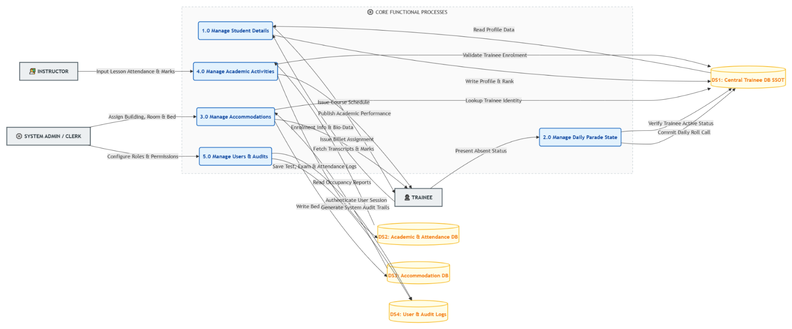
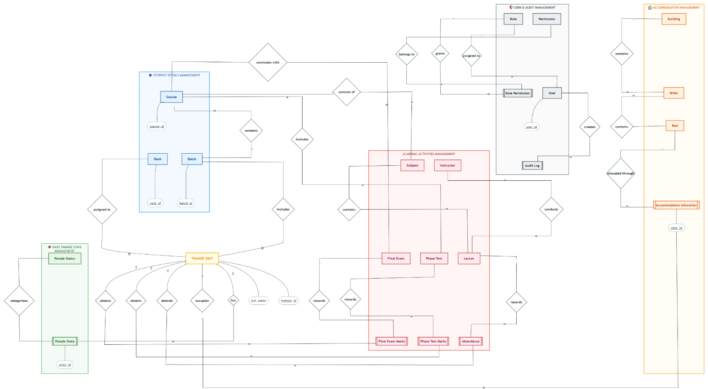

15 | Executive Summary
The SLAF Trade Training School (TTS) Management Portal is a centralized, web-based management information system engineered specifically to resolve data fragmentation, redundant clerical processing, and operational latency within the Sri Lanka Air Force Trade Training School. Historically, operational data spanning trainee personal records, trade categorizations, course scheduling, batch configurations, daily accountability states, classroom attendance, academic evaluation marks, accommodation allotments, and disciplinary or personal occurrences were maintained via disparate register entries, isolated local spreadsheets, and manual clerical returns.
This portal establishes an integrated institutional environment where information entered in one operational area dynamically populates and validates downstream military and academic processes without data re-entry. Key operational capabilities unified within the system include:
Trainee Master Indexing: Centralized service profiles and personal records acting as the single source of truth across all modules.
Curriculum & Batch Administration: Structured courses tied directly to specific trades, with automated duration calculations, dedicated classroom allotments, and centralized lesson plan document storage via secure cloud infrastructure.
Dual-Tiered Daily Accountability: A Morning Parade State submission and approval hierarchy feeding the official school Daily Strength figures, operating alongside a distinct Evening Roll Call (Night Parade) workflow that displays baseline morning states as read-only references and enforces explicit evening check-ins.
Academic Evaluation Lifecycle: End-to-end management of classroom attendance registries, phase test assessments, final examination marks, and automated academic progress tracking visualized chronologically.
Logistics & Personal Occurrences: Top/Bottom bunk allocation within designated billets, and an audit-traceable record of personal achievements and offenses/misconduct.
Role-Based Access Control (RBAC): Strict operational segregation among Administrators, Instructors, Officers In-Charge (OIC), and Officers Commanding Training (OCT).
By transitioning the training establishment from localized, disconnected ledgers to an integrated relational data architecture, the TTS Management Portal ensures total command visibility, auditable historical tracking, and accurate accountability across the training lifecycle.

16 | Problem Statement
The Trade Training School conducts continuous, multi-tier technical and basic formations across numerous trades simultaneously. Analysis of baseline operations reveals several key structural deficiencies:
  - Information Distribution Across Disparate Repositories: Training records, daily parade states, classroom attendance rolls, and disciplinary registers reside in independent physical logbooks and decentralized workstation spreadsheets across individual training wings.
  - Clerical Duplication and Data Drift: The same basic trainee parameters (e.g., Service Number, Rank, Name, Trade, Course Intake) are manually re-entered across Morning Parade returns, class attendance sheets, test mark sheets, and billet registries. This redundancy introduces clerical errors and inconsistencies between administrative records.
  - Latency in Daily Strength Compilation: Verifying the physical location and state of hundreds of airmen and recruits across categories (Present, Hospitalized, Sick in Quarters, Absent Without Leave, Course Visit, Authorized Leave) requires time-consuming manual tallying of individual trade returns, delaying prompt reporting to Headquarters.
  - Disconnection Between Morning and Evening Accountability: No automated system verifies that evening roll call accounts for personnel movements during the day (e.g., a trainee sent to the hospital during afternoon training) while maintaining the original morning submission untouched.
  - Decentralized Academic and Performance History: Cross-referencing a trainee’s attendance reliability with phase test performances or physical billet occurrences requires manual collation of files from separate instructional and administrative offices.
  - Absence of Role-Controlled Traceability: Physical paper registries lack granular access controls, leaving sensitive disciplinary occurrences and academic modifications vulnerable to unauthorized access and without verifiable digital audit trails.

17 | Aim and Objectives
To design, engineer, and deploy a robust, secure, centralized web-based management information portal that unifies trainee master administration, training curriculum structures, academic performance evaluation, multi-tier daily physical accountability, and facility logistics across all operational trades within the SLAF Trade Training School.

System Objectives
- Centralize Trainee Master Data: Establish an authoritative relational database repository for trainee personal, service, and trade records that acts as the single source of truth for all modules.
- Automate Daily Physical Accountability: Implement trade-wise digital Morning Parade State submission and instructor approval workflows that compute the official institutional Daily Strength automatically.
- Implement Night Parade Reconciliation: Deploy an evening roll call module that preserves the Morning Parade State as a read-only baseline while recording, updating, and saving evening trainee locations.
- Streamline Curriculum and Batch Logistics: Manage trade-to-course hierarchies with automated batch duration calculation derived from validated start/end dates, eliminating manual date-drift.
- Digitize Academic Progress & Attendance: Provide integrated classroom attendance registers, Phase Test evaluation logs, and visual academic progress profiling tied directly to trainee master files.
- Enforce Two-Tier Accommodation Tracking: Manage billet and room assignments down to individual bunk allocations, distinguishing systematically between "Top" and "Bottom" bunks.
- Control Occurrence Record Access: Maintain role-restricted registers for trainee Achievements and Misconduct/Offenses, preserving chain-of-command accountability without exposing disciplinary notes broadly.
- Enforce Role-Based Access Control (RBAC): Ensure operational functions are strictly segregated between Administrators, Instructors, OICs, OCTs, and general training staff via secure authentication and route guards.
- Eliminate Redundant Clerical Input: Design system workflows where data recorded upstream (such as assigned batch instructors or morning sickness states) automatically pre-fills downstream tasks.
- Ensure System Traceability and Scalability: Maintain complete chronological audit trails of user sign-ins and state approvals, while engineering a containerized, database-backed foundation ready for future institutional scale.

18 | Users and Roles
The system uses Role-Based Access Control (RBAC) to ensure that users access only the features required for their specific military and instructional duties. Unauthorized access attempts trigger a structured Access Denied response
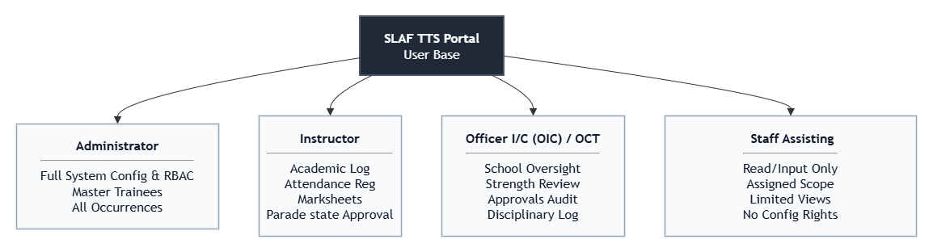
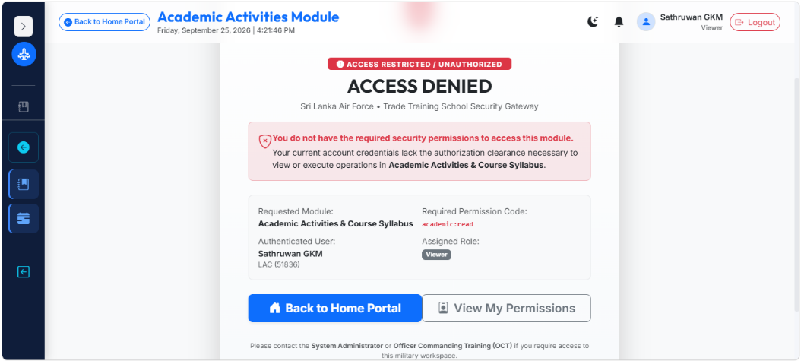

- Administrator
Role Summary: The technical authority responsible for system health, user lifecycle, and institutional governance.
Core Responsibilities:
  - Provisioning, activating, and deactivating user credentials across all ranks.
  - Maintaining granular role mappings and assigning system permissions.
  - Defining institutional master configurations (Trades, Classrooms, Blocks, Billets).
  - Reviewing global audit logs and monitoring login histories.
  - Executing safe data migration and system administration protocols.

2. Instructor
Role Summary: Technical non-commissioned officers (SNCOs/JNCOs) and instructional officers actively directing courses of instruction.
Core Responsibilities:
  - Managing classroom-level attendance registers for allocated batches.
  - Recording and reviewing lesson plans and associated training literature.
  - Reviewing, verifying, and formally approving or returning submitted Morning Parade States for their allocated batch.
  - Recording phase test marks, module evaluations, and exam assessments.
  - Logging academic remarks, trainee commendations, and preliminary occurrences.

3. Officer In-Commanding (OIC) / Officer Commanding Training (OCT)
Role Summary: Commissioned officers exercising executive training oversight, institutional command, and discipline over training wings.
Core Responsibilities:
  - High-level visibility across the central Executive Dashboard.
  - Monitoring live trade-wise Daily Strength, hospital admissions, and AWOL states.
  - Tracking outstanding, pending, and returned Parade State submissions school-wide.
  - Overseeing full personal occurrence records (Achievements, Misconduct, Disciplinary inquiries).
  - Authorizing formal academic standing, review boards, and batch completions.

4. Other Authorized Operational Users (Parade state Clerks / Wing Staff)
Role Summary: Designated administrative personnel responsible for routine clerical entries.
Core Responsibilities:
  - Inputting trade-wise Morning Parade submissions for instructor review.
  - Executing the Night Parade (Evening Roll Call) module and saving physical counts.
  - Entering initial trainee master demographics during intake processing under supervision.

19 | System Overview & Operational Flow
The TTS Management Portal operates on an authenticated, decoupled architecture. Operational execution follows a strict pipeline: a user must successfully authenticate, retrieve an identity context containing authorized permissions, and navigate through a dashboard-first interface. Access attempts outside assigned permissions are blocked at both the UI routing level and API endpoints.

20 | Core system modules & functionalities
Purpose
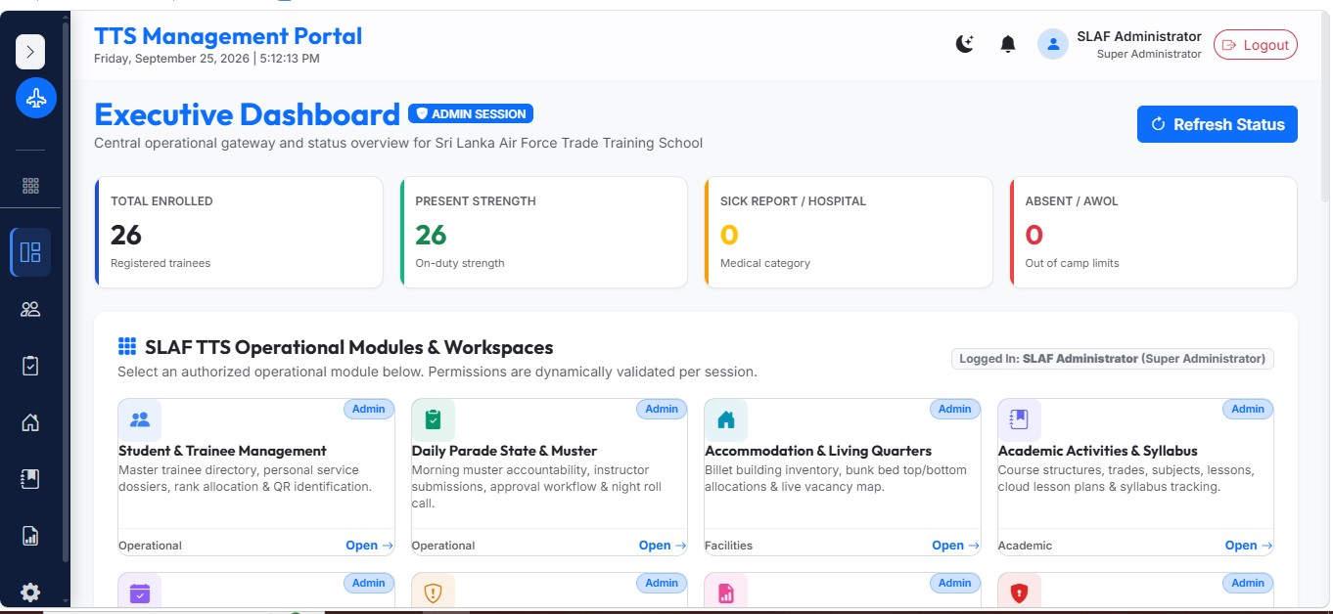
The Executive Dashboard serves as the primary operational landing portal for command, administrative, and instructional authorities. It synthesizes cross-modular operational indicators into real-time key performance indicators (KPIs), summary metric cards, visual charts, and direct navigation links, eliminating manual data collation from separate departments.

Main Functions
Live Strength Accountability Cards: Displays active trainee totals categorized dynamically by daily muster status (Present, Sick Report, Hospital, Leave, AWOL) derived strictly from approved returns.
Academic Health Indicators: Aggregates average Phase Test performance, pass/fail percentages, and syllabus completion velocity across active courses.
Facility Utilization Tracking: Summarizes real-time bed capacity and occupancy percentages across all billets.
Priority Operational Feeds: Lists pending Parade State submissions awaiting approval and immediate disciplinary/medical flags (e.g., AWOL, Hospital admissions).

Main Users
Commanding Officer (CO)
Officer Commanding Training (OCT)
Officer In-Charge (OIC) Training Wings
System Administrators
Important Workflow
User logs in; upon identity validation, the portal loads the Executive Dashboard.
The frontend triggers GET /api/v1/parade/summary, GET /api/v1/academic/dashboard-summary, and GET /api/v1/accommodation/dashboard.
Aggregated metrics populate dashboard metric cards and Chart.js visual containers.
Clicking any KPI card navigates the user to the corresponding operational module with the selected status filter applied.
Relationship with Other Modules
Integrates data directly from Trainee Master (students), Parade State (parade_submissions), Academic Assessments (exam_marks), and Accommodation (accommodation_allocations).
Important Data Handled
Aggregate trainee counts, daily muster category sums, average academic pass margins, total living capacity, and active notification queues

Trainee Details Management
Purpose
Acts as the authoritative, Single Source of Truth (SSOT) master directory for all military personnel enrolled in training at the SLAF Trade Training School. It centralizes personal, service, medical, and contact records, eliminating duplicate record-keeping across administrative sections.

Main functions
- Trainee Directory & Filtering: Searchable index paginated across Service Number, Rank, Trade, Course, Batch, and operational status (On parade, Sick, Leave, AWOL, Passed Out).
- Trainee Enlistment & Registration: Captures validated bio-data, service enlistment specifics, NIC, emergency contact details, and military medical classifications.
- Main Users
- Discipline Section NCOs & Clerks
- Academic Section Staff
- System Administrators
- Important Workflow
- Administrative clerk accesses /students and selects Add New Trainee (/students/new).
- Active enrollment options load via GET /api/v1/academic/courses/enrollment-options (excluding closed courses).
- User inputs service particulars; the backend validates uniqueness of the Service Number and NIC via POST /api/v1/students.
- The system generates a digital QR code payload, saves the record, writes an immutable STUDENT_CREATED audit log, and redirects to the profile page.
Relationship with Other Modules
- The students record serves as the root foreign key across parade_states, academic_attendance, exam_marks, accommodation_allocations, and personal_occurrences.
- Important Data Handled
- Service Number (Unique), Rank, Full Name, NIC, Trade, Enrolled Course ID, Batch, Blood Group, Medical Category, Contact Information, QR Payload.

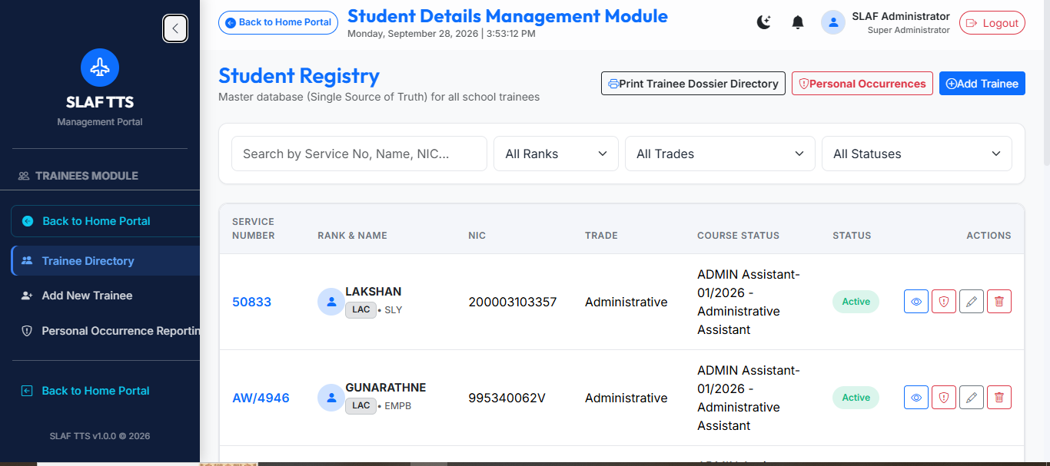

Personal Academic Profile
Purpose
- Provides a consolidated academic dossier for an individual trainee, compiling enrolled trade specifications, batch schedules, evaluation marks, and phase assessments into a unified record.
Main Functions
- Course Cohort Summary: Displays active Course Code, Course Title, Batch intake, assigned Classroom, and Course Instructor.
- Chronological Assessment Index: Lists all Phase Tests and Final Examinations completed by the student.
- Eligibility Audit Display: Flags whether exam entries were sat under regular eligibility or authorized via formal officer override.
- Official Dossier Compilation: Generates a server-side compiled A4 PDF Trainee Dossier combining academic, attendance, and disciplinary metrics.
Main Users
- Instructors
- Academic Section Officers
- Commanding Officer / OCT
Important Workflow
- User navigates to a trainee's profile (/students/:id) and opens the Academic Profile tab.
- The UI queries GET /api/v1/students/{student_id} and GET /api/v1/students/{student_id}/academic-progress.
- The server joins courses, batches, subjects, and exam_marks to render completed modules, marks, percentages, and SLAF grades.
Relationship with Other Modules
Aggregates relational data from Course Management (courses), Batch Configurations (batches), and Examination Management (exams, exam_marks).
Important Data Handled
Course Title, Batch Name, Subject Codes, Max Marks, Marks Obtained, Grade, Pass/Fail Standing, Officer Override Notes.
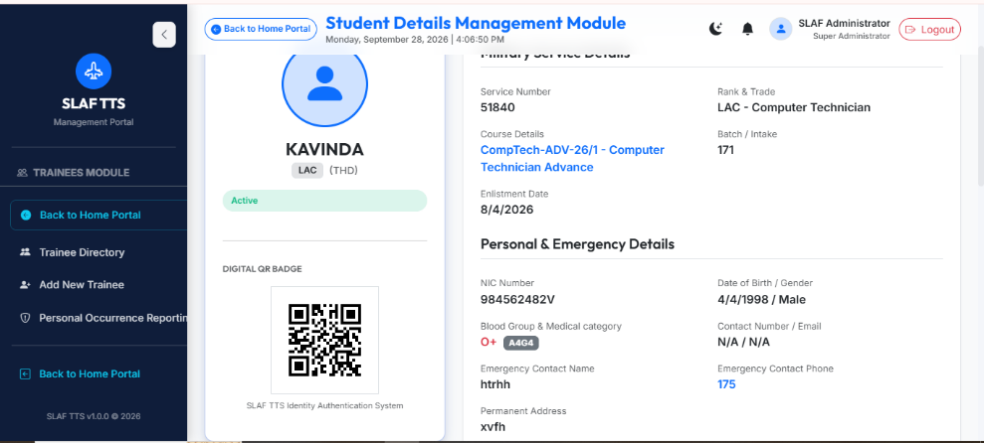

Trade Management
Purpose
Maintains the master registry of military vocational specializations (trades) recognized within the SLAF Trade Training School, ensuring courses and cohorts remain categorized under official Air Force trade branches.
Main Functions
- Trade Registry (CRUD): Creation and maintenance of official trade titles (e.g., Airframe, Avionics, Safety Equipment, Engine, Administrative, Logistical).
- Trade-Course Mapping: Links vocational trades directly to specific syllabi and course curricula.
- Trade-Level Strength Grouping: Provides trade-level filters for Daily Strength and Morning Parade reports.
Main Users
- Academic Section Administrators
- Super / System Administrators
Important Workflow
- Academic administrator navigates to /academic and opens the Trades sub-view.
- The UI retrieves active trades via GET /api/v1/academic/trades.
- User adds a trade by submitting the trade title and code via POST /api/v1/academic/trades.
- The system validates uniqueness, saves the record to the trades table, and updates trade selection dropdowns across the portal.
Relationship with Other Modules
Parent entity for Course Management (courses), Batch Cohorts (batches), and Trainee Master profiles (students. Trade).
Important Data Handled
Trade ID (UUID), Trade Code, Trade Name, Description, Active Status Flag.
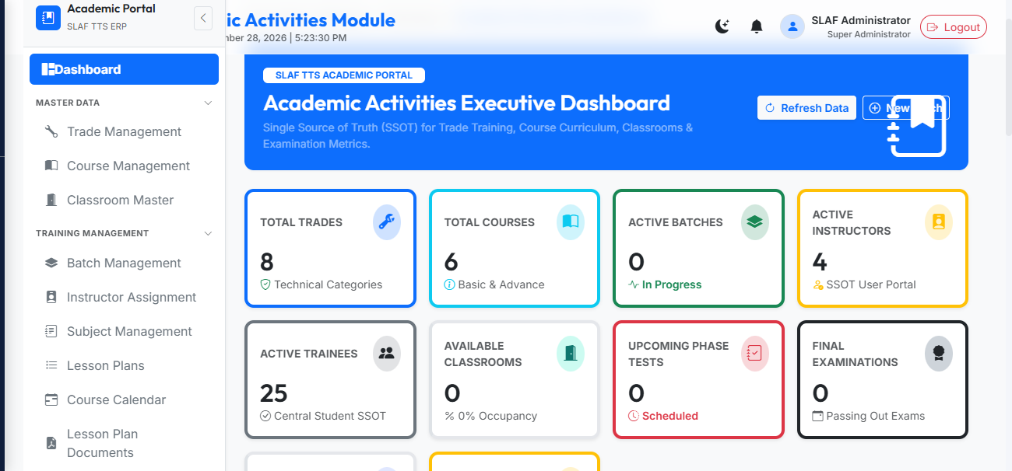
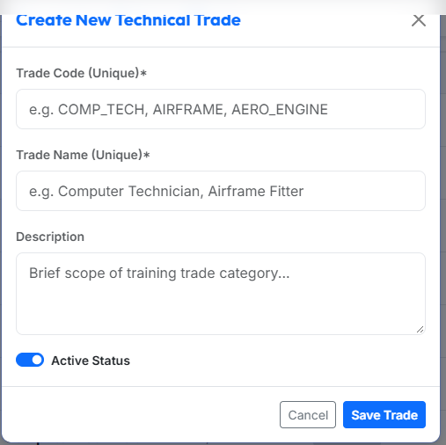

Course Management
Purpose
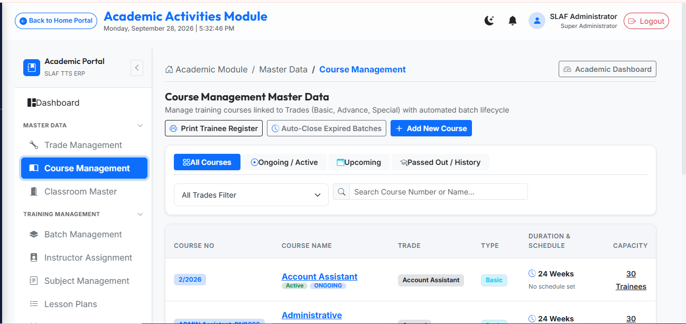
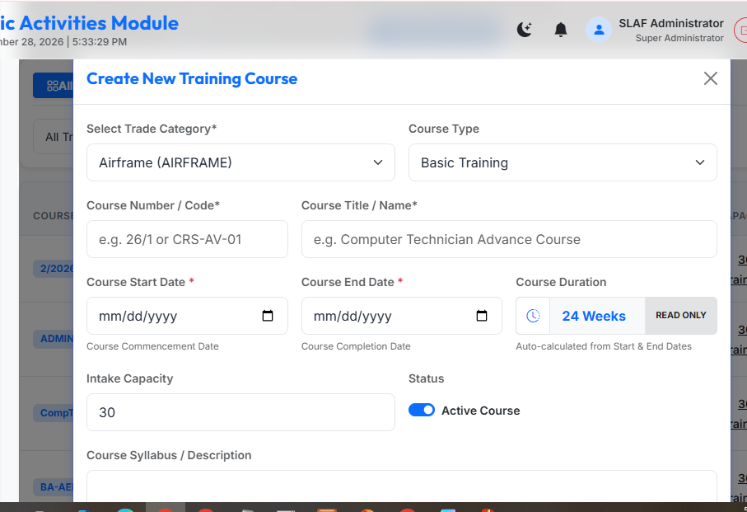
Governs the creation, scheduling, and cataloging of formal training programs within each trade, defining duration boundaries, intake capacities, and structural syllabus.

Main Functions
- Course Cataloging: Defines course codes, names, trade associations, and classifications (Basic, Advance, Special).
- Lifecycle Tracking: Categorizes courses through operational states (UPCOMING, ONGOING, PASSED OUT).
- Capacity and Boundary Definition: Establishes intake student capacities alongside official start and end dates.

Main Users
- Academic Section Staff
- Officer Commanding Training (OCT)
Important Workflow
- User opens the Course Management view and inputs course details (e.g., Code: BA-AER-01, Title: Basic Airframe Mechanics Course).
- Form captures Trade association, Course Type, Start Date, and End Date.
- Upon clicking Save, the frontend submits payload to POST /api/v1/academic/courses.
- The system validates date ranges, calculates duration in weeks, saves the record to courses, and refreshes the course catalog.
Relationship with Other Modules
Directly child to Trade Management (trades); parent to Batch Management (batches), Subjects (subjects), Exams (exams), and Course Calendars (course calendar).
Important Data Handled
- Course Code, Course Title, Trade ID, Course Type, Duration Weeks, Intake Capacity, Start Date, End Date, Status (ONGOING, PASSED OUT).

